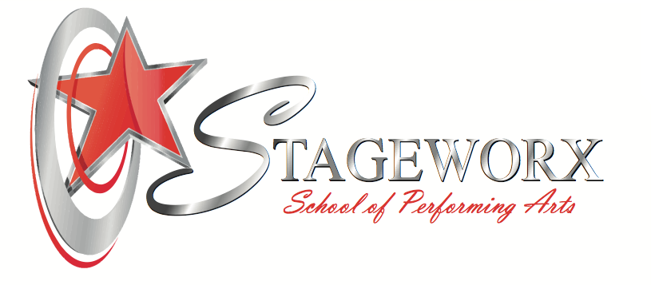

STAGEWORX PERFORMING ARTS INTRODUCTION

2020 FULL TIME “INDUSTRY 101” COURSES & TRAINING

Stageworx have selected a variety of group and private training classes, not only to provide our budding performers a chance to expose them to the industry, but also train their disciplines for a possible future career in the arts industry. The selection of training and courses will support the students in developing their skills and obtaining a direction, in line with their personal attributes and passions as an artist and performer.

The “Industry 101” course is aimed at artists and performers who are seeking to develop a career in Performing Arts. The course is open to school leavers and students who are following a distance learning academic curriculum. Many classes are scheduled and planned for the mornings; however, a strong sense of determination, pro-active approach and self-motivation is required to balance the individual students’ arts training, deadlines, rehearsals, and external schooling effectively.

A great deal of emphasis is placed on developing communication skills, organizational skills and encouraging self-discipline and development. We aim to produce disciplined performers who are self-motivated and driven towards goals.

Stageworx training and exposure have supported students in securing roles and performing in Musical Theatre Productions, TV and Film and the Music Industry. Other student successes lead to securing training in overseas establishments, discovered a love and passion for teaching, videography, photography or simply found their personal direction through their arts training. Selected students remain with Stageworx and continue their training and development for a second or third year, altering programs and class selections in alignment with their interests.

Stageworx encourage the motto of “learning through doing”. Learners and students are given the opportunity to attend professional auditions, experience the process and identify their performance shortfalls and areas of growth. Classroom training can only teach so much, the actual “doing”, determines the qualities and growth required to fully understand the beauty of a career in the Arts. Auditions are not secured or guaranteed, as some auditions are open to the whole school where other auditions are based on selections according to a brief, dedication and commitment to classes and work ethic.

Kindly refer to the Stageworx Terms and Conditions, School Ethos, Fee Structures, registration fees and uniform requirements, for full preparation and knowledge of Stageworx and the training facility.

INDUSTRY 101 - FULL TIME PACKAGE
(Pricing VAT inclusive)
Term 1 & 2 – Training | Term 3 & 4 – Training | Monthly Fee (over 12 months)
Private Trinity Examination Class  Grade 8, ATCL or LTCL choice of Musical Theatre or Performance Arts (Dependant on level upon entry)  (If ATCL or LTCL, group theory class will be included) Musical Theatre Group  - Ensemble Singing  - Modern Dance  - Hip Hop Dance  - Music Theory  - The Art of Singing  - Business of the Arts  - Body Con  - Acting for Stage & Screen  - Open Dance  Plus : Select 3 options below  - Ballet  - African Dance  - Audition Technique  - Acting through Song  - Music Production  - Improvisation  1 x 30min Private per week from the below  (note if audition technique is optioned REPETOIRE will be the private)  (If Music Production is optioned SONGWRITING or INSTRUMENT will be the private)  - Songwriting  - Open Dance Development  - Piano  - Guitar  - Vocal Repertoire | Private Trinity Examination Class  ATCL or LTCL choice of Musical Theatre or Performance Arts (Dependant on level upon entry)  (If ATCL or LTCL, group theory class will be included)  - Musical Theatre Group  - Ensemble Singing  - Modern Dance  - Hip Hop Dance  - Music Theory  - Business of the Arts  - Body Con  - Acting for Stage & Screen  - Open Dance  Plus : Select 3 options below  - Ballet  - African Dance  - Audition Technique  - Acting through Song  - Music Production  - Improvisation  STUDENTS WILL COMPLETE PRIVATE DEVELOPMENT PROJECT FOR TERM 3 & 4 – 1 x hour private per week  Teacher will be selected according to project.  Examples of project:-  - Original Song Release  - Original Song and Music Video Release  - Showreel - Musical Theatre  - Showreel - Acting  - Teaching Project  - Directing Project  Further Internship request | R7,400.00 p.m.  9 % Discount offered for upfront annual payment  (by 31st Dec 2020)

“INDUSTRY 102” FULL TIME PACKAGE
(Upon completion of 101 Course)
(Pricing VAT inclusive)
CLASSES | Monthly Fee  (over 12 months)
Private Trinity Examination Classes  ATCL or LTCL choice of Musical Theatre Or Performance Arts –  (Dependant on level upon entry)  (If ATCL or LTCL, group theory class will be included)  Select 8 classes below:-  - Musical Theatre Group  - Ensemble Singing  - Modern Dance  - Hip Hop Dance  - Music Theory  - Business of The Arts  - Body Con  - Acting for Stage & Screen  - Open Dance  - Ballet  - African Dance  - Audition Technique  - Acting Through Song  - Music Production  - Improvisation  1 x Private Development Lesson per week  Teacher will be selected according to project.  Project Examples:-  - Original Song Release  - Original Song and Music Video Release  - Showreel - Musical Theatre  - Showreel - Acting  - Teaching Project  - Directing Project  - Further Internship request | R5,750.00 p.m.  9 % Discount offered for upfront annual payment (by 31st Dec 2020)

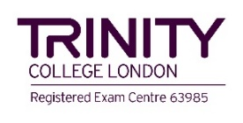

TRINITY COLLEGE LONDON MUSICAL THEATRE AND PERFORMANCE ARTS
GRADED AND CERTIFICATE TRAINING

Stageworx Performing Arts are an approved and registered Trinity College London Examination Centre. We offer training in both the Musical Theatre and Performing Arts Categories.

Musical Theatre and Performance Arts qualifications are suitable for candidates of all ages who wish to demonstrate successful growth and progression of their performance skills, knowledge and understanding.

Trinity College London specialize in the assessment of communicative and performance skills covering music, drama, combined arts, and English language. With over 850,000 candidates a year in more than 60 countries worldwide, Trinity qualifications are specifically designed to help students progress. The aim is to inspire teachers and learners through the creation of assessments that are enjoyable to prepare for, rewarding to teach and that develops the skills needed in real life.

Musical Theatre training and examinations are for the performers who LOVE all aspects of Musical Theatre. Private classes are a combination of singing, dancing, and acting, linking these skill sets together according to the Trinity Syllabus.

Performing Arts training is more diverse and open. Students are encouraged to write and develop their own material such as poetry, choreography, make-up for stage, music video, creation, acting, singing, dancing – any form that the individual would like to develop and present / perform.

Trinity graded exams are designed to provide a structured learning framework that enables beginners gradually to develop skills up to an advanced level.

Initial assessments on candidates will indicate the correct grade entry according to the Trinity Syllabus. Advanced grades may be followed in either Musical Theatre or Performance Arts

Associate Trinity College London Diploma & Licentiate Trinity College London Diploma training and qualifications are also offered through Stageworx Performing Arts.

Whilst teaching and training the Trinity Syllabus, a great deal of emphasis is placed on communication skills, organization, and self-development. Students are required to practice and prepare for deadlines and classes.

For more information on Trinity College London, refer to https://www.trinitycollege.com

